Ainjelle Anne D. Ordoñez IPT2

WMA-4B September 22, 2023

**INSTRUCTIONS.** Read the steps first before doing them.

Screenshot every steps. Do not crop your screenshots. 30 Points.

1. Create a GitHub account (10 Points)

1. On your account, create a repository named *Lastname_Firstname_Year&Section* (2 Points)
   * Your repository should be public (1 Point)
   * Add a short description (1 Point)
   * Note: Check “Initialize this repository with a README” (1 Point)

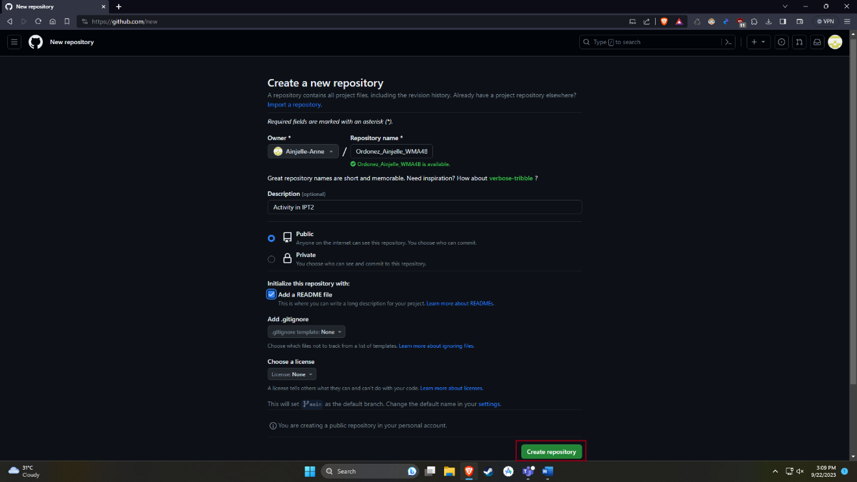

1. On the left side, click the “Branch”
   * On the right side, click “New Branch”
   * Branch name should be “September 22 2023 IPT2 Activity” (5 Points)
   * Note: Do not change the source
   * Then Create (5 Points)

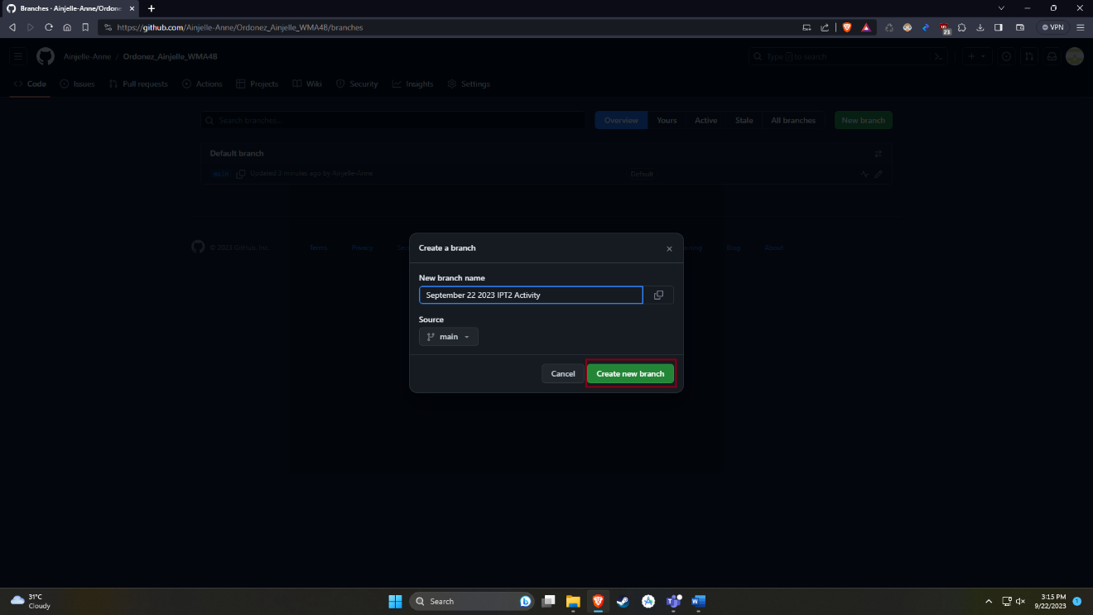

1. Under the September 22 2023 IPT2 Activity
   * On the right side, click the “Add file”
   * Then upload the document file of your activity. (3 Points)
   * File name should be *Lastname_Firstname_DateOfTheActivity_Year&Section* (2 Points)



